Standard Operating Procedure
Step-by-Step Workflow Documentation

Step 1: Step 1
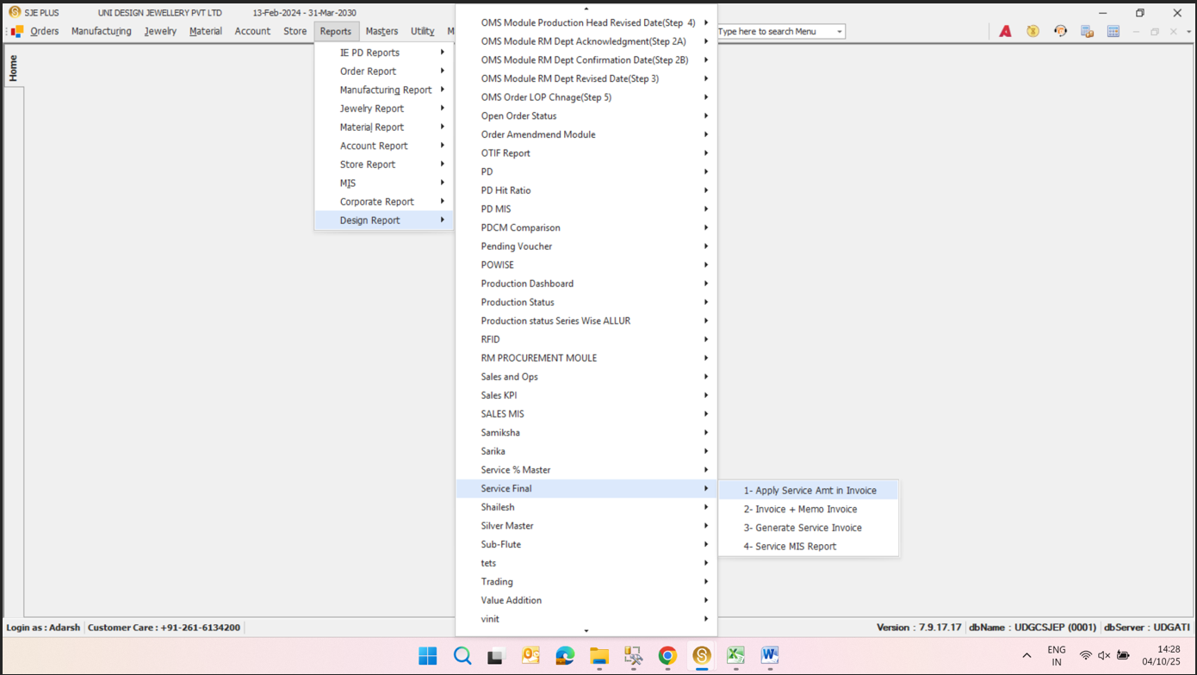
**1- Apply Service Amt in Invoice**
Key objects & actions:
- **1- Apply Service Amt in Invoice** —
- **2- Invoice + Memo Invoice** —
- **3- Generate Service Invoice** —
- **4- Service MIS Report** —

Step 2: Step 2
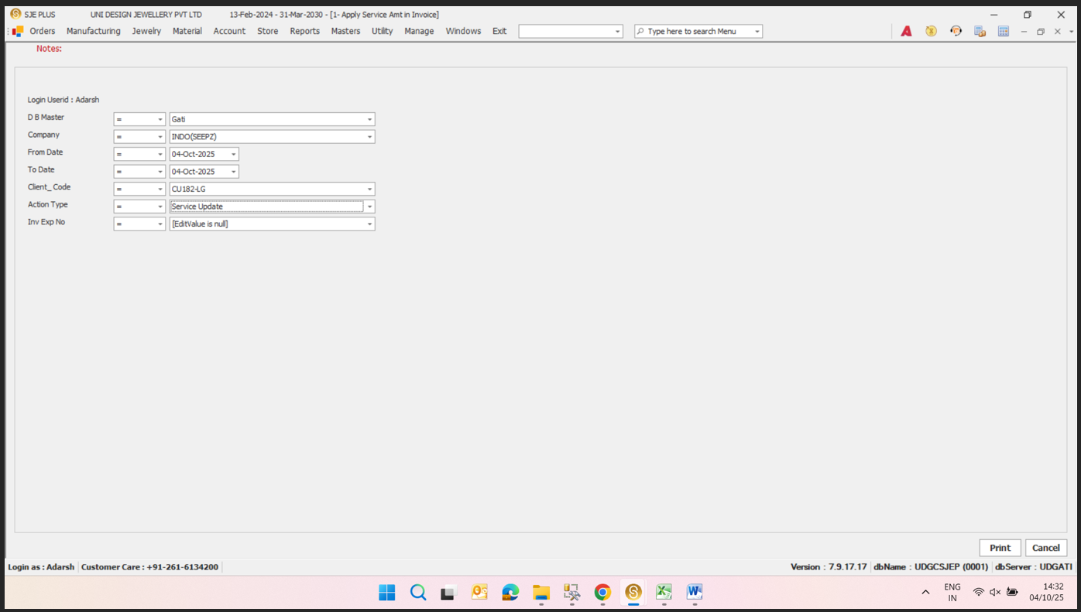
**Login**
Key objects & actions:
- **Login** — The user is logged in as "Adarsh."
- **Select Menu** — The user is in the "Orders" section.
- **Action Type** — The action type is set to "Service Update."
- **Date Range** — The date range is set from "04-Oct-2025" to "04-Oct-2025."
- **Client Code** — The client code is set to "CU182-G."
- **Invoice Number** — The invoice number is set to "null."
- **Print** — The user can print the form.
- **Cancel** — The user can cancel the process.

Step 3: Step 3
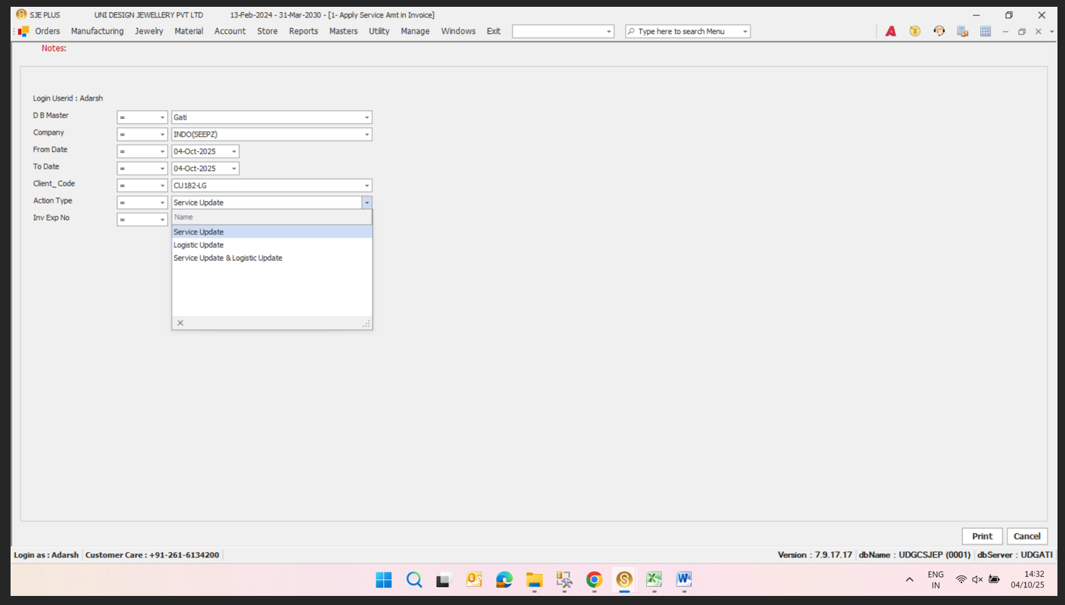
Service Update
Key objects & actions:
- Service Update —
- Logistic Update —
- Service Update & Logistic Update —

